

|  |  |  |
| --- | --- | --- |
| **Java 2** |  | |
| **Faculty of Applied Computing and Technology** | | **Assignment #2** |

**Best Luck!**

Build your own study guide for the upcoming exam. The study guide should cover everything we have covered so far.

I will give marks for clarity, thoroughness, and organization of this document. **The best guides will get the best marks!** Think about it this way, the better a job you do on this document, the better the mark you will get on this assignment and the better the mark you will get on the exam when you study from this document.

I suggest that you use a screen clipping tool to include sample code in your study guide. A free screen clipping tool that I use is at <http://getgreenshot.org>. Feel free to use any one you wish.

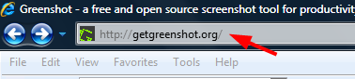 I used greenshot to capture this.

**Feel free to take information from the course slides**, **textbook, web etc**., **You may also use Chatgpt in your research**. **However, the entire study guide must be written in your own words.**

**Study guides that are copied and pasted from chatgpt or other websites will receive a failing grade. You can use diagrams and slides from the web but the explanations must be written in your own words.**

**Please submit your word doc to Slate with the following name:**

**<<yourName>>StudyGuide.doc**

**For instance, RichSmithStudyGuide.doc**